**VISVESVARAYA TECHNOLOGICAL UNIVERSITY**

**“JnanaSangama”, Belgaum -590014, Karnataka.**



**LAB REPORT**

**on**

**Database Management Systems (23CS3PCDBM)**

***Submitted by***

**Jayasheela (1BM25CS460)**

***in partial fulfillment for the award of the degree of***

**BACHELOR OF ENGINEERING**

***in***

**COMPUTER SCIENCE AND ENGINEERING**



**B.M.S. COLLEGE OF ENGINEERING**

**(Autonomous Institution under VTU)**

**BENGALURU-560019**

**Sep-2024 to Jan-2025**

**B.M.S. College of Engineering,**

**Bull Temple Road, Bangalore 560019**

(Affiliated To Visvesvaraya Technological University, Belgaum)

**Department of Computer Science and Engineering**



**CERTIFICATE**

This is to certify that the Lab work entitled “Database Management Systems (23CS3PCDBM)” carried out by **Jayasheela (1BM25C460),** who is bonafide student of **B.M.S. College of Engineering.** It is in partial fulfillment for the award of **Bachelor of Engineering in Computer Science and Engineering** of the Visvesvaraya Technological University, Belgaum. The Lab report has been approved as it satisfies the academic requirements in respect of a Database Management Systems (23CS3PCDBM) work prescribed for the said degree.

|  |  |
| --- | --- |
| Lab faculty Rashmi H  Assistant Professor  Department of CSE, BMSCE | Dr Kavitha sooda  Professor & HOD  Department of CSE, BMSCE |

**Index**

|  |  |  |
| --- | --- | --- |
| **Sl.**  **No.** | **Experiment Title** | **Page No.** |
| 1 | Insurance Database | 4-10 |
| 2 | More Queries on Insurance Database | 11-13 |
| 3 | Bank Database | 14-21 |
| 4 | More Queries on Bank Database | 22-24 |
| 5 | Employee Database | 25-32 |
| 6 | More Queries on Employee Database | 33-34 |
| 7 | Supplier Database | 35-38 |
| 8 | NO SQL – Restaurant Database | 41-45 |

**PROGRAM 1: INSURANCE DATABASE**

Person (driver_id: string, name: string, address: string)

Car (reg_num: string, model: string, year: int)

Accident (report_num: int, accident_date: date, location: string)

Owns (driver_id: string, reg_num: string)

Participated (driver_id: string,reg_num: string, report_num: int, damage_amount: int)

## SCHEMA DIAGRAM

i. Create the above tables by properly specifying the primary keys and the foreign keys.

CREATE DATABASES

Query:

Create Tables:

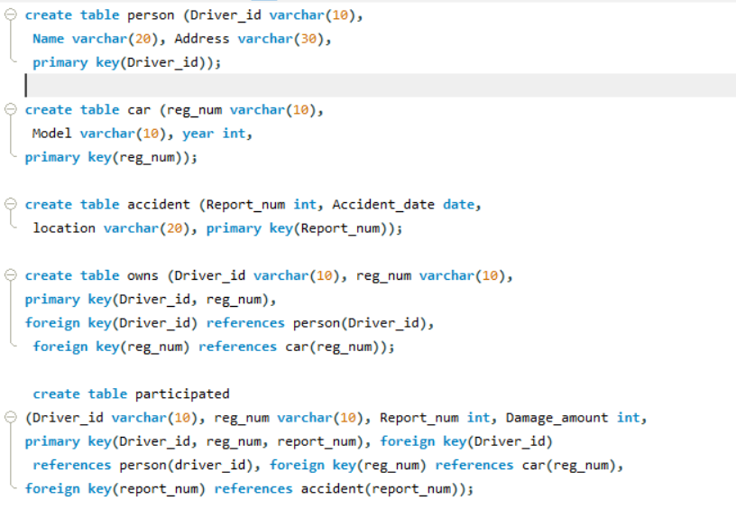

**STRUCTURE OF THE TABLES:**

****

**INSERTING VALUES TO THE TABLE:**

ii. Enter at least five tuples for each relation.

**Person table:**

****

**Car Table:**

**Accident Table:**

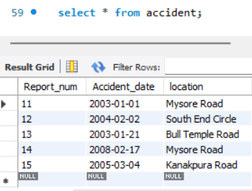

**OwnsTable:  
  
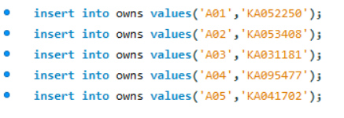**

**Participated table:**

**iii.** Display Accident date and location

iv. Update the damage amount to 25000 for the car with a specific reg-num for which the accident report number was 12.

v. Add a new accident to the database.

vi. Display driver id who did accident with damage amount greater than or equal to Rs.25000

**Program 2. More Queries on Insurance database**

**i.** Display the entire CAR relation in the ascending order of manufacturing year.

ii. Find the number of accidents in which cars belonging to a specific model (example 'Lancer') were involved.

iii. Find the total number of people who owned cars that were involved in accidents in 2008.

iv.List the entire participated relation in the descending order of damage amount.

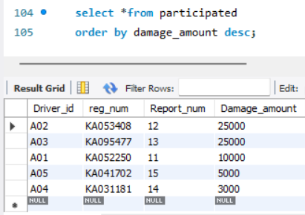

v.Find the average damage amount

vi.Delete the tuple whose damage amount is below the average damage amount

*vii. List the name of drivers whose damage is greater than the average damage amount.*



vii. Find maximum damage amount.

**Program 3:bank database**

**Shema Diagram:**

Branch (branch-name: String, branch-city: String, assets: real)

BankAccount(accno: int, branch-name: String, balance: real)

BankCustomer (customer-name: String, customer-street: String, customer-city: String)

Depositer(customer-name: String, accno: int)

Loan(loan-number: int, branch-name: String, amount: real)

**CREATE TABLES:**

i. Create the above tables by properly specifying the primary keys and the foreign keys.

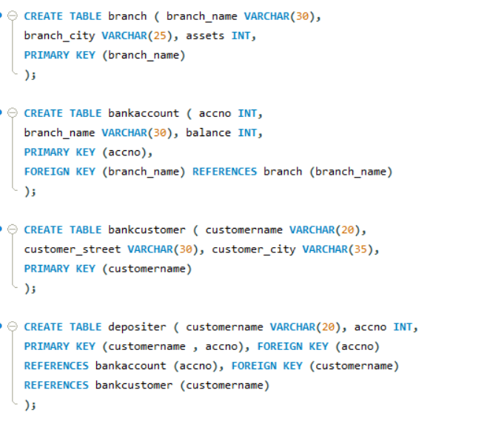

**STRUCTURE OF THE TABLES:**

**INSERTING VALUES TO THE TABLE:**

ii. Enter at least five tuples for each relation.

**Branch table :**

**Bankaccount Table:**

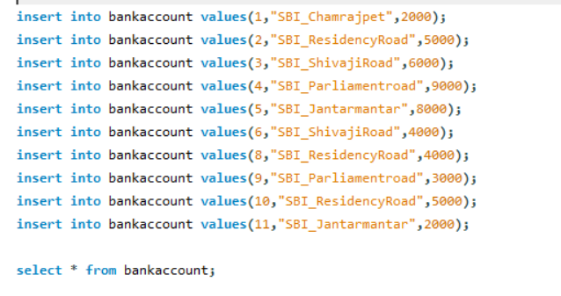

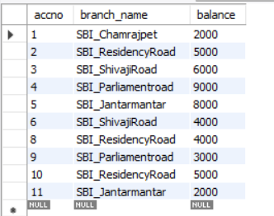

Banckcustomer Table:

**Depositor Table:**

**Loan Table:**

**Borrower Table:**

iii. Display the branch name and assets from all branches in lakhs of rupees and rename the assets column to 'assets in lakhs'.

iv. Find all the customers who have at least two accounts at the same branch (ex. SBI_ResidencyRoad).

v. Create a view which gives each branch the sum of the amount of all the loans at the branch.

**Program 4:More Queries on bank Database**

i. Find all the customers who have an account at all the branches located in a specific city (Ex. Delhi).

ii.Find all customers who have a loan at the bank but do not have an account.

iii. Find all customers who have both an account and a loan at the Bangalore brach.

iv. Find the names of all branches that have greater assets than all branches located in Bangalore.

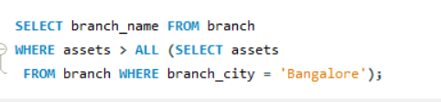

v. Demonstrate how you delete all account tuples at every branch located in a specific city (Ex. Bombay).

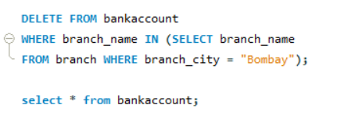

vi. Update the Balance of all accounts by 5%

**Program 5:Employee Database**

**ER Diagram:**

**Schema Diagram:**

**Create Database:**

i. Using Scheme diagram, create tables by properly specifying the primary keys and the foreign keys.

Create Tables:

###### *STRUCTURE OF TABLE:*

ii. Enter greater than five tuples for each table.

Dept table:

Employee Table:

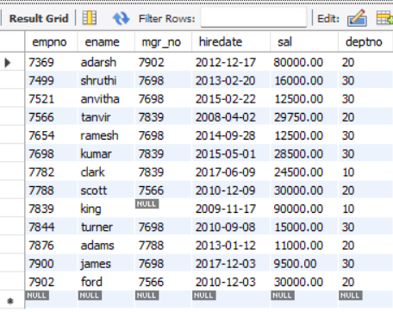

Incentives Table:

Project Table:

Assigned_to Table:

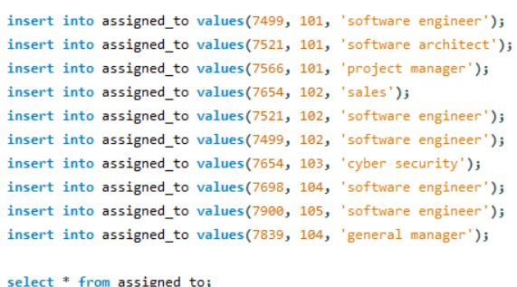

iii. Retrieve the employee numbers of all employees who work on project located in Bengaluru, Hyderabad, or Mysuru

iv. Get Employee ID’s of those employees who didn’t receive incentives

v. Write a SQL query to find the employees name, number, dept, job_role, department location and project location who are working for a project location same as his/her department location.

**Program 6: More Queries on Employee Database**

i. List the name of the managers with the maximum employees

ii. Display those managers name whose salary is more than average salary of his employee.

iii. Find the name of the second top level managers of each department.

iv. Find the employee details who got second maximum incentive in January 2019.

v. Display those employees who are working in the same department where his manager is working.

**Program 7: Supplier database**

###### *Create Database:*

i. Using Scheme diagram, create tables by properly specifying the primary keys and the foreign keys.

###### *Create tables:*

###### *Structure of tables:*

ii. Insert appropriate records in each table.

**Program Database :8**

i. Find the pnames of parts for which there is some supplier.

ii. Find the snames of suppliers who supply every part.

iii. Find the snames of suppliers who supply every red part.

iv. Find the pnames of parts supplied by Acme Widget Suppliers and by no one else.

vi. Find the sids of suppliers who charge more for some part than

the average cost of that part (averaged over all the suppliers who supply that part).

vii. For each part, find the sname of the supplier who charges the most for that part.

**NoSQL:**i. Write NoSQL Queries on “Restaurant” collection

ii. Write a MongoDB query to display all the documents in the collection restaurants.

iii. Write a MongoDB query to arrange the name of the restaurants in descending along with all the columns.

iv. Write a MongoDB query to find the restaurant Id, name, town and cuisine for those restaurants which achieved a score which is not more than 10.

v. Write a MongoDB query to find the average score for each restaurant.

vi. Write a MongoDB query to find the name and address of the restaurants that have a zip code that starts with '10'.



